**ifstream example**

https://www.youtube.com/watch?v=Iho2EdJgusQ

#include "stdafx.h"

#include <iostream>

#include <fstream>

#include <string>

using namespace std;

int main()

{

ifstream inFile;

inFile.open("line.txt");

if (inFile.fail()) {

cerr << "Error opening file" << endl;

exit(1);

}

string item;

int count = 0;

//Read a file until you've reached the end

while (! inFile.eof()) {

inFile >> item;

count++;

}

cout << count << " number of objects found!" << endl;

inFile.close();

return 0;

}

**line.txt:**

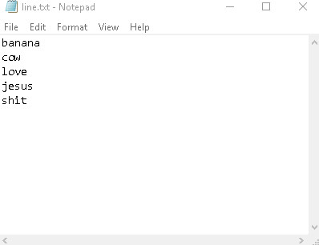

**Result:**

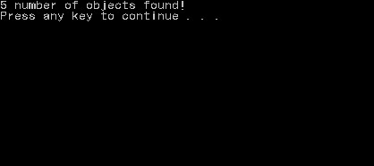

**Important notes:**

* Never forget parenthesis when calling functions ()
* Always close the stream, be it out file stream or in file stream
* Use while (! inFile.eof()) to read everything. The eof() returns true when the end of file is reached